**WEEK -01**

1> **DESIGN PATTERN**

* **Exercise 1: Implementing the Singleton Pattern**

🡺CODE:

Logger.java

public class Logger {

    private static Logger instance;

    private Logger() {

    }

    public static Logger getInstance() {

        if (instance == null) {

            instance = new Logger();

        }

        return instance;

    }

    public void log(String msg) {

        System.out.println("log: " + msg);

    }

}

Test.java

public class Test {

    public static void main(String[] args) {

        Logger lg1 = Logger.getInstance();

        Logger lg2 = Logger.getInstance();

        if(lg1 == lg2){

            System.out.println("\nSame instance\n");

        } else {

            System.out.println("\ndifferent instance\n");

        }

        lg1.log("check your inbox\n");

    }

}

**O/P:**

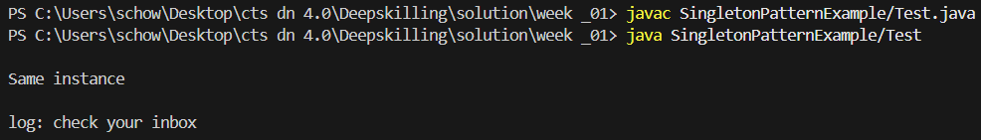

* **Exercise 2: Implementing the Factory Method Pattern**

🡺CODE:

Document.java

public interface Document {

    void open();

    void close();

}

WordDocument.java

public class WordDocument implements Document {

    @Override

    public void open() {

        System.out.println("Word is opening\n");

    }

    @Override

    public void close() {

        System.out.println("Word is closing\n");

    }

}

PdfDocument.java

public class PdfDocument implements Document{

    @Override

    public void open() {

        System.out.println("Pdf is opening\n");

    }

    @Override

    public void close() {

        System.out.println("Pdf is closing\n");

    }

}

ExcelDocument.java

public class ExcelDocument implements Document{

    @Override

    public void open() {

        System.out.println("Excel is opening\n");

    }

    @Override

    public void close() {

        System.out.println("Excel is closing\n");

    }

}

DocumentFactory.java

public abstract class DocumentFactory {

    public abstract Document createDocument();

}

WordDocumentFactory.java

public class WordDocumentFactory extends DocumentFactory {

    @Override

    public Document createDocument(){

        return new WordDocument();

    }

}

PdfDocumentFactory.java

public class PdfDocumentFactory extends DocumentFactory{

    @Override

    public Document createDocument() {

        return new PdfDocument();

    }

}

ExcelDocumentFactory.java

public class ExcelDocumentFactory extends DocumentFactory{

    @Override

    public Document createDocument() {

        return new ExcelDocument();

    }

}

Test.java

public class Test {

    public static void main(String[] args) {

        WordDocumentFactory wordFactory = new WordDocumentFactory();

        Document word = wordFactory.createDocument();

        word.open();

        word.close();

        PdfDocumentFactory pdfFactory = new PdfDocumentFactory();

        Document pdf = pdfFactory.createDocument();

        pdf.open();

        pdf.close();

        ExcelDocumentFactory excelFactory = new ExcelDocumentFactory();

        Document excel = excelFactory.createDocument();

        excel.open();

        excel.close();

    }

}

O/P:

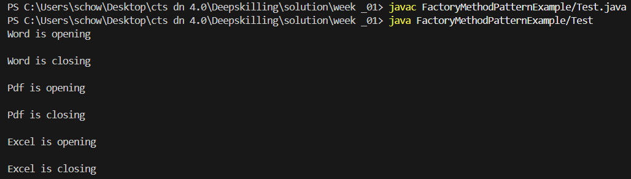

--------------------------------------------------------------------------------------------------------

2> **Algorithms and Data Structures:**

* **Exercise 2: E-commerce Platform Search Function**

**🡺**Solution:

* Big-oh: describes the upper bound (worst-case) of a function when the argument tends towards larger values. It is used to classify algo according to how their run-time or space requirement grow as input(n) grows.

|  |  |  |  |
| --- | --- | --- | --- |
| Name | Best-case | Avg-case | Worst-case |
| Linear Search | O(1) | O(n) | O(n) |
| Binary Search | O(1) | O(logn) | O(logn) |

**Code:**

BinarySearch.java

public class BinarySearch {

    public static Product binSearch(Product[] pdts, int id) {

        int s=0;

        int e = pdts.length - 1;

        while (s <= e) {

            int mid = (s + e) / 2;

            if (pdts[mid].productId == id) {

                return pdts[mid];

            } else if (pdts[mid].productId < id) {

                s = mid + 1;

            } else {

                e = mid - 1;

            }

        }

        return null;

    }

}

LinearSearch.java

public class LinearSearch {

    public static Product linSearch(Product[] pdts, int id){

        for (Product pdt : pdts) {

            if (pdt.productId == id) {

                return pdt;

            }

        }

        return null;

    }

}

BubbleSort.java

public class BubbleSort {

    static void sort(Product[] arr) {

        int n = arr.length;

        for (int i = 0; i < n; i++) {

            for (int j = 0; j < n - i - 1; j++) {

                if (arr[j].productId > arr[j + 1].productId) {

                    Product p = (arr[j+1]);

                    arr[j+1] = arr[j];

                    arr[j] = p;

                }

            }

        }

    }

    static void printArr(Product[] arr) {

        for (int i = 0; i < arr.length; i++) {

            System.out.println(arr[i]);

        }

    }

}

Main.java

public class Main {

    public static void main(String[] args) {

        Product[] pdts = {

            new Product(1, "AC", "Appliances"),

            new Product(3, "Cards", "Toys"),

            new Product(2, "Deodrants", "Beauty"),

            new Product(4, "Smart watch", "Gadgets")

        };

        System.out.println("Linear Search: ");

        Product pdt = LinearSearch.linSearch(pdts, 4);

        System.out.println(pdt);

        System.out.println();

        BubbleSort.sort(pdts);

        System.out.println("products list after sorting id:");

        BubbleSort.printArr(pdts);

        System.out.println();

        System.out.println("Binary Search: ");

        Product pdt2 = BinarySearch.binSearch(pdts, 3);

        System.out.println("found pdt: "+ pdt2);

    }

}

**O/P:**

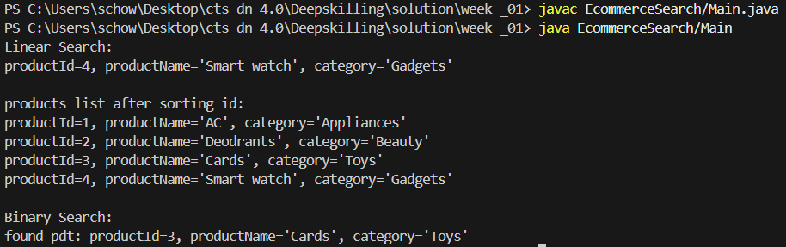

* Both linear and binary search have their pros and cons.
* In case of linear search no sorting is required but it’s worst case time complexity[O(n)] is more than binary search[O(logn)] . So, it may perform bad to large number of datasets.
* In case of binary search a sorting is needed beforehand. But it’s avg and worst case time complexity is better than linear search. So, it may perform good to large number of datasets, but if frequent updation occurs in database then it may take more time due to running consequent sorting.
* So, the searching algo is solely dependent on the application requirement. In my case, E-commerce will need frequent updation so I will go for linear search.
* **Exercise 7: Financial Forecasting**

**🡺Solution:**

* Recursion is a technique of programming where on function calls itself again and again until a base case is satisfied. It breaks larger problem into smaller number of problems using recursion stack.

Two step is there: i> selecting a base case: a condition to stop infinite looping and return certain outputs, ii> selecting a recursive case where function calls itself with modified arguments.

* Recursion simplifies problems which have natural recursive structures(e.g, factorial, tree traversal) by breaking down the problem in smaller subproblems and solve the problem with ease.

**Code:**

Finance.java

import java.util.Scanner;

public class Finance {

    public static double calculate(double val, double rate, int year) {

        if (year == 0) {

            return val;

        }

        return calculate((val + val * rate), rate, year - 1);

    }

    public static void main(String[] args) {

        Scanner sc = new Scanner(System.in);

        System.out.print("Enter current value: ");

        float currentVal = sc.nextFloat();

        System.out.print("Enter growth rate: ");

        float rate = sc.nextFloat();

        System.out.print("Enter the number of years: ");

        int year = sc.nextInt();

        double val = calculate(currentVal, rate, year);

        System.out.println(val);

    }

}

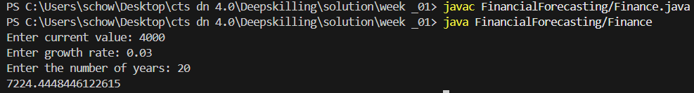**O/P:**

* Time complexity: O(n), where n is the number of years up to which growth rate is performed
* We can use memoization where we save function call for a specific input and when that function is called with the same input we can retrieve it in constant time.